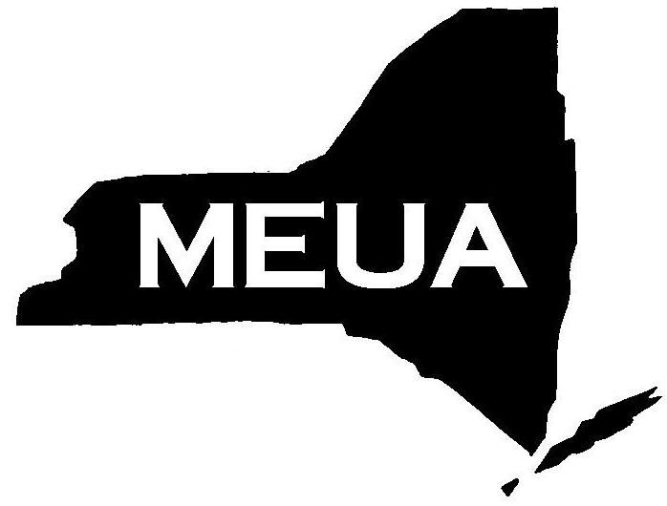
Municipal Electric Utilities
Association of New York State
6652 Hammersmith Drive, East Syracuse, New York, 13057
Phone: 315-453-7851 Fax: 315-453-7849
Email: info@meua.org web site: www.meua.org

TO: Member Systems
FROM: Narin Kowalski
DATE: July 29, 2026
RE: New! Year 1 LINEWORKER APPRENTICE PROGRAM REGISTRATION

MEUA and Northeast Public Power Association (NEPPA) are pleased to announce that we will be starting a new Lineworker Apprentice Program to begin April 2022 in Fairport.

The classes are (member-- $3,700.00), (non-member-- $4,575.00), per student- per year and will consist of four sessions, four days each, with hands on training and bookwork. This is a 4-year program and students will be given substantial homework. Classes will be held from 8:00am to 2:00pm.

The 1st Year Apprentice Lineworker Program classes will be held April through October 2022.

Please fill out and fax or email the completed form below as soon as possible. Additionally, we need a Student Enrollment Application (attached), on file. A few of you are expecting a new hire and, therefore, do not have a name to register. In this case, please make that note on the registration form and return it to the MEUA offices. If there are any questions, please call.

1st YEAR LINEWORKER APPRENTICE PROGRAM

System_________________________________________________

Authorized Signature____________________________________

Student Name | Sweatshirt Size | Notes
1.
2.
3.
4.

